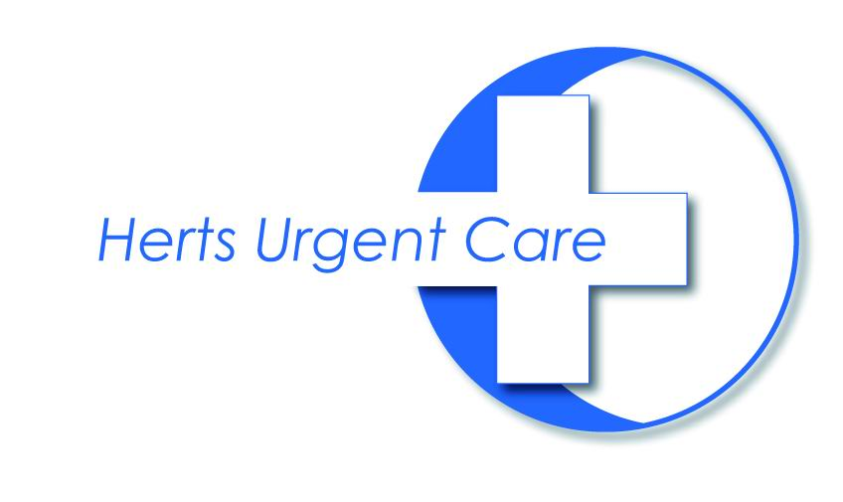

Putting local GPs at the start and heart of out of hours care

- Calls answered by our highly trained call handlers in our Welwyn Garden City call centre.
- Initial clinical assessment will be carried out by experienced, local GPs,
- Patients will have a choice of attending any of our 10+ Primary Care Centres which are located so as to ensure all residents of Herts are within 30 minutes travelling time, thereby providing care as close to home as possible. Where this is not possible, we are working on cross-border agreements with neighbouring providers.
- GPs will also be supported by a team of drivers in fully equipped vehicles based at agreed PCCS, to allow prompt home visiting to anywhere in the county when clinically necessary.

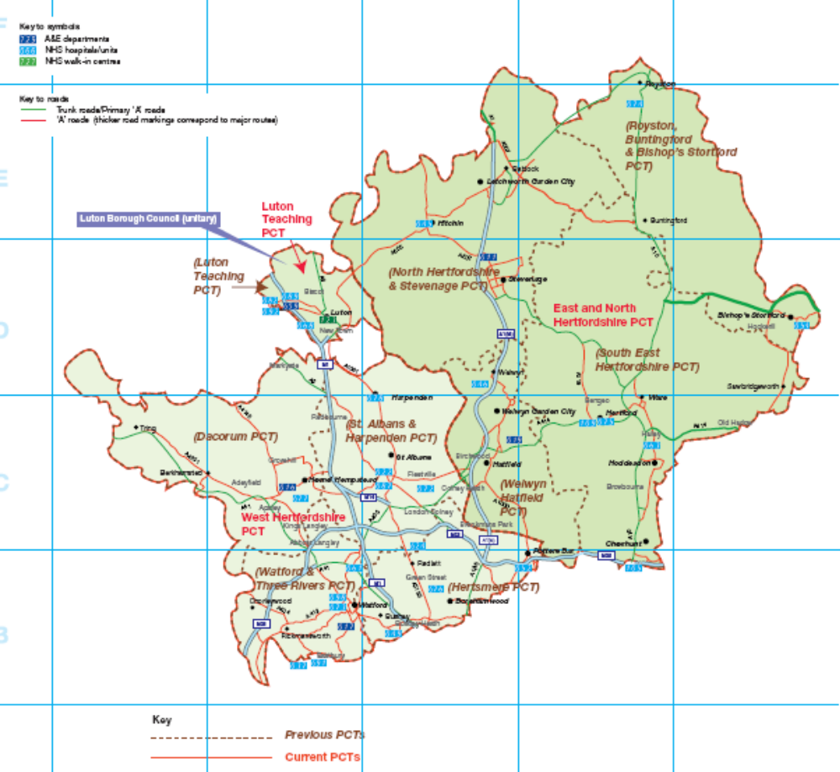
Information Technology and Communications

HUC operates a fully electronic system, using Adastra software. Full training will be provided to GPs who wish to work with HUC.

All telephone calls in and out of HUC are recorded, and our call management system ensures the best possible response times and minimises the likelihood of a patient being unable to contact us.

Our experience and integration into the local health community

We have a proven track record of delivering high quality out of hours care in Hertfordshire over the past 10 years as our constituent organisations, Herts Out of Hours Service (HOOHS), StarDoc and the PCT provider service (North Herts & Stevenage and Welwyn Hatfield localities). As such we have excellent relationships with the PCT, and our local GP practices. We hope to extend this relationship to the parts of West Herts which are new to us.

We will cultivate good relationships with local GP practices by maintaining good communication with practices, and engage the local GPs by offering fair rates of pay for out of hours work, and enabling them to become involved in the governance and direction of HUC at the local Quality & Safety Groups.

Ensuring a safe, high quality service

Several Q&S Groups will be established, covering all areas. These groups will review local clinical governance arrangements and issues, ensuring we maintain a local focus on clinical quality and safety.

Our constitution

HUC is a Community Benefit Society; a not for dividend organisation which is governed by a Council of Members, drawn from the local GP workforce, our staff, patients and stakeholders (such as the Ambulance Service, NHS Direct and intermediate care services).

HUC is considered part of the NHS family, and as such is eligible to contribute to the superannuation scheme on behalf of GPs and staff. GPs work on a self-employed basis for HUC, booking shifts according to their own availability directly through the website, according to our eligibility and booking guidelines.


